MongoDB:
-Nosql -> Not only sql
-unstructured and semi structured data can be stored
-Uses JSON-like format called BSON-> Binary JSON
-we write json like->Internally BSON by MongoDB
- record/row is document
-table is collection
-database is database in MongoDB
-Stores huge amount data
-No join or foreignkey kind of things..data is nested inside
-Relevent Data is grouped/nested inside
-No normalisation concept..so huge data consumption…minus of mongoDb

MongoDB Server:
-data is stored here
-manages entire dbs
MongoDB Compass:
-GUI for managing DBS and connections
-Provides direct tool to manage instead of queries
MongoDB Shell:
-cli for performing queries
-available in compass only..i.e embbedded

Creating Database:
- cmd:- use db_name
-creates if exists
-if exists-> navigates to it
-Imp: a database can be visible if it has atleast 1 collection in it
Show Databases:
-cmd:- show dbs
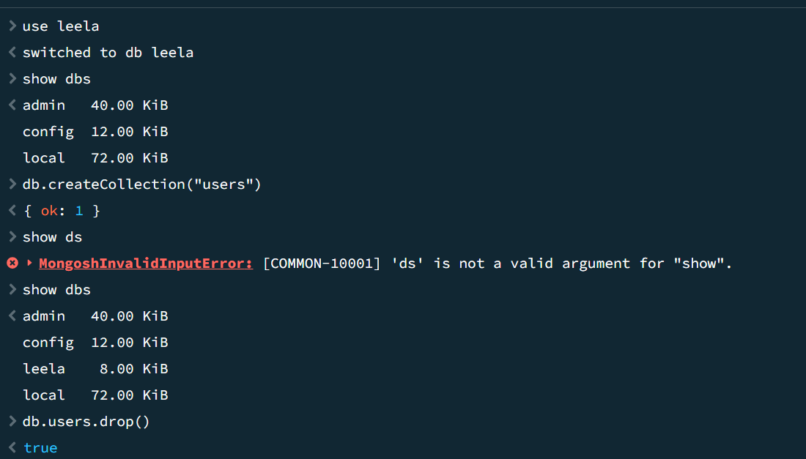
Dropping Database:
-first navigate to respective db
-cmd:- db.dropDatabase()
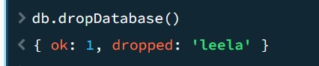

Create Collection:
-cmd:- db.createCollection(“name”)
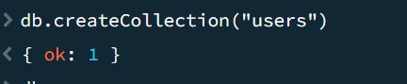
Drop Collection:
-cmd:- db.collection_name.drop()
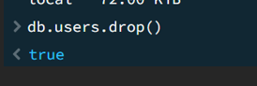
Rename Collection:
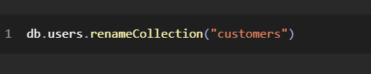
Alter:
-uses runCommand
-Mainly we use schema validation
-Rename Database:
-no direct method
-copy and delete old one
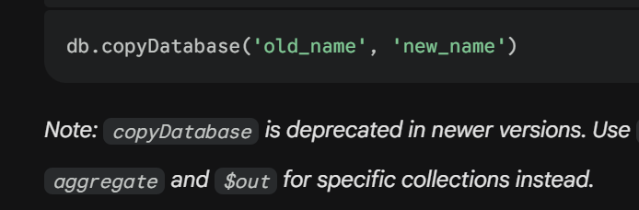
Insert one Document:
-cmd:- db.collection_name.insertOne({})
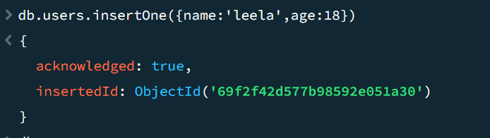
Insert Many Documents:
-cmd:- db.collection_name.insertMany([{},{}])
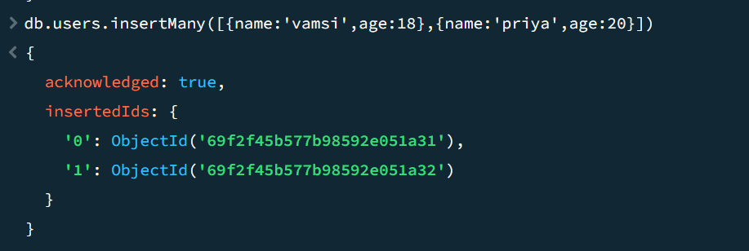
List Documents of a collection:
-cmd:- db.colle_name.find()
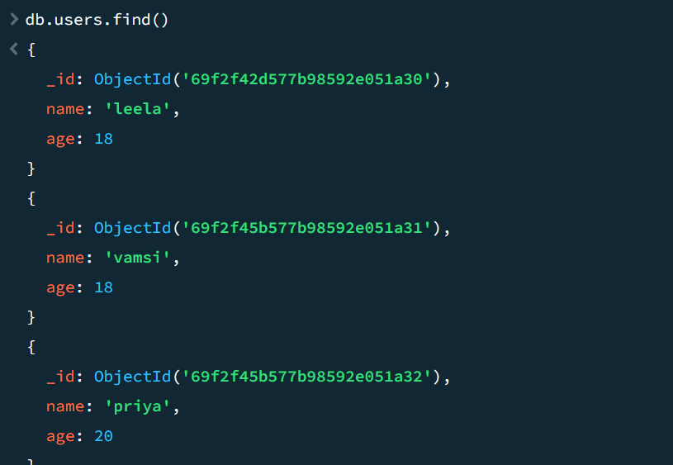
_id:
-24 chars
_id is automatically generated by MongoDB for each document
-uses ObjectId class internally
-we can create if we want
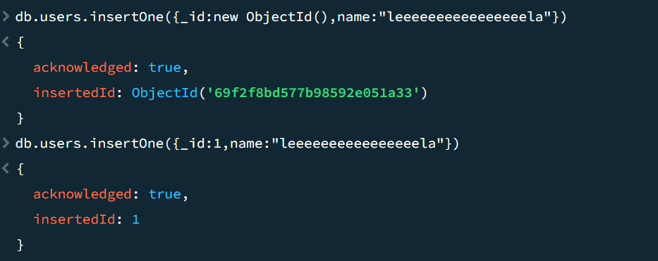
When we see…
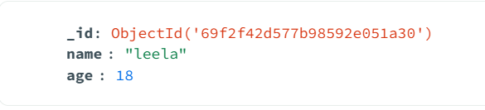
Clear Commands:
-cmd:- cls
-clear shell

Data Types:
1.string
2.int
3.double
4.long
5.date
6.boolean
7.Arrays (hetro)
8. nested data /object
9. null
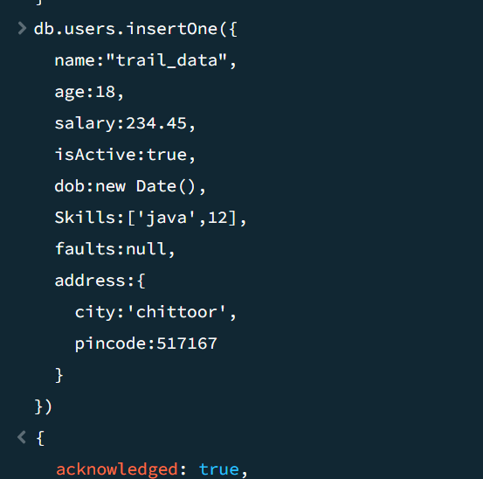
Find()
-To have access to document of a collection..
-default->returns all document
-find(query)->return matching
-find(query,projection data)->returns documents that are matching with specific project data key value pairs
Query->key value pair to match
Project data->key with Boolean,..true/1->shows,…false/0->hides..
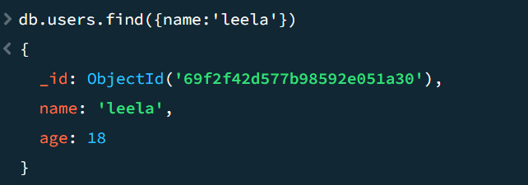
-returns name=’leela’
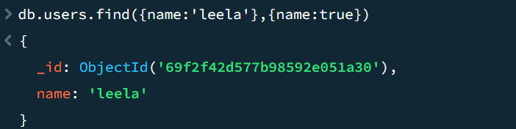
-returns only name since we kept name:true…rest by default false..except id
TO stop id:
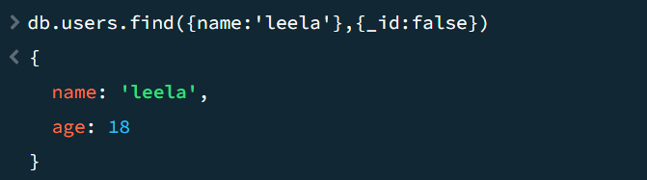
findOne(query,projection data):
-returns only 1st data

Accessing Nested Object:
Cmd:db.coll_name.find({“nestobj.key”:value})

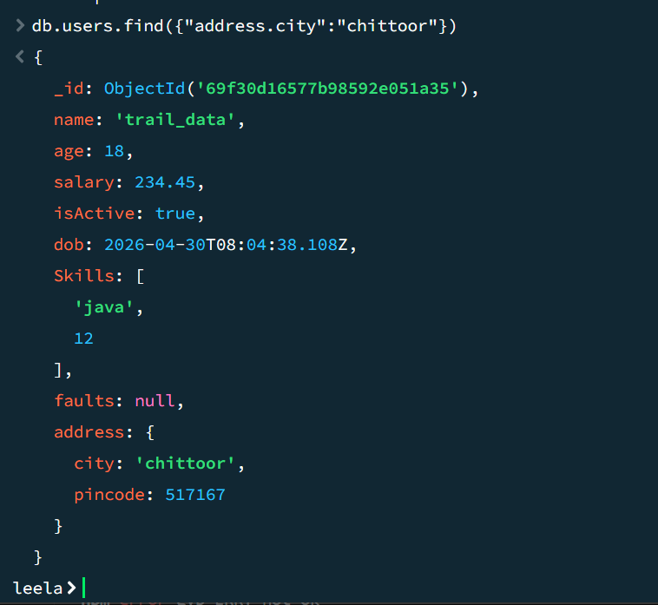
Sort():
-used for sort based on query
-mostly used with find()
- 1 for asc and -1 for desc

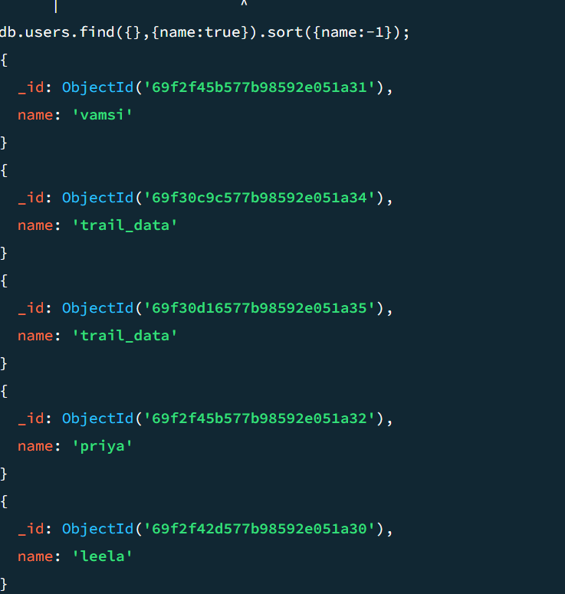
Limit:
-limts the documents
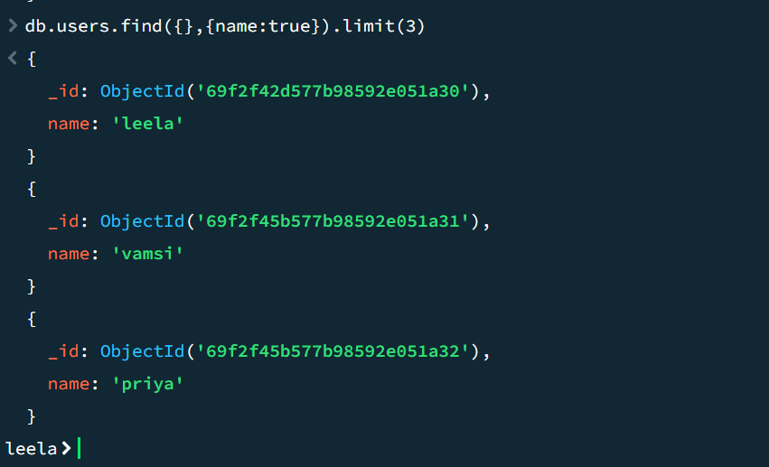
Skip(n):
-skip n documents and return rest

-also can do limit(1).skip(2)..order does not matter
Pretty():
-proper readable way of displaying
-currently depreciated

Count():
-used to get count
-used with find(filter)
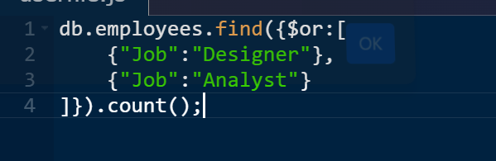
-used in older version..
CountDocuments(filter)
-new version count
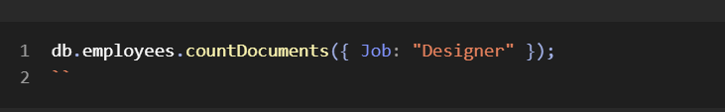
Updating Documents:
1.updateOne(filter,set/unset object):
-used for update data for 1 matching document
-filter takes key value in {} to filter
-$set for adding/modifying value
-$unset for removing the key-value from the document
-$inc for increment.
-$push for add data to array..
-RHS for set/unset should be present
-RHS for $inc should be numeric
-No decrement ..so use $inc with negative value
-many set/unset is ok..many filter option ok..
But internally it only updates 1st matching document
-does not matter which data type you had…any new data type can be applied

2.updateMany(filter,set/unset:object):

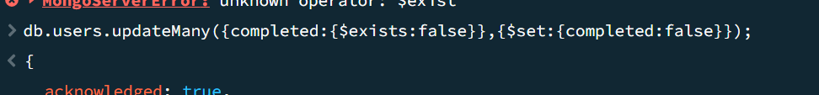
3.replaceOne(query,replacing data):
-replaces the document

4.findOneAndUpdate(filter,update,options):
-updates and give data
-default returns old data..not updated
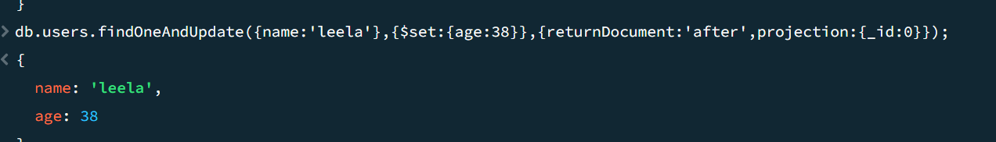
Options: this is 3rd arg…used only in update related stuff as 3rd arg
returnDocument:”before”|”after” //return doc before updation or after
Projection:{} takes object for projection
Upsert:Boolean
//upsert is insert+update
Try to update/replace if filtered document exists
If not exists-> adds document with update data
5. findOneAndReplace
-replace instead of update
-filter,replace,options
-rest is same
Update operators:
Each operator should be used only once
1.set
2.unset
3.inc
4.push
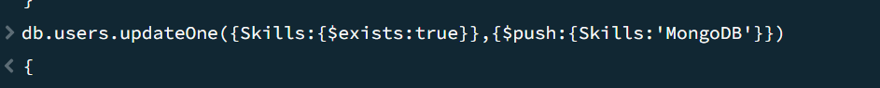
Note For Update:
-To add array at index use set with arr_name.index
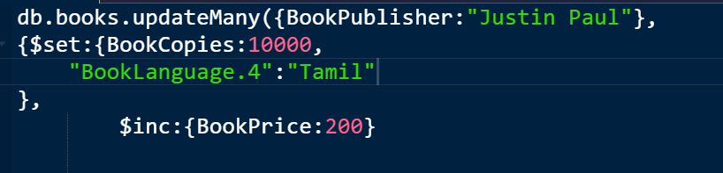
-adds tamil at index 4…but filling null if less than 4…

Deleting :
deleteOne(filter):
-first and single deletion
deleteMany(filter):
-deletes all which fliter matches
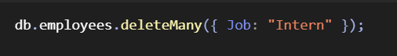
Comparision Operators:
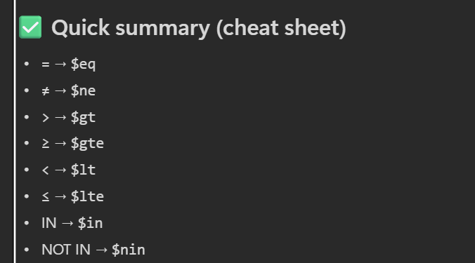
Syntax:
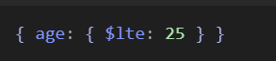
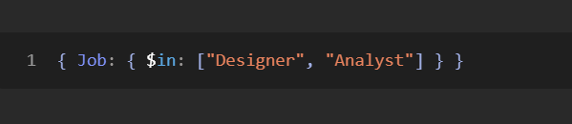
-IN and NIN takes array
Applying Multiple Opertaors to each field:
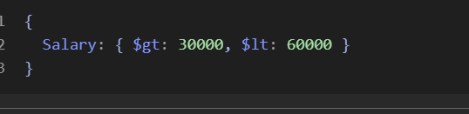
Logical Operators:
1. $and ->takes []
2.$or ->takes []
3. $not ->takes a condtion
4. $nor->takes arr
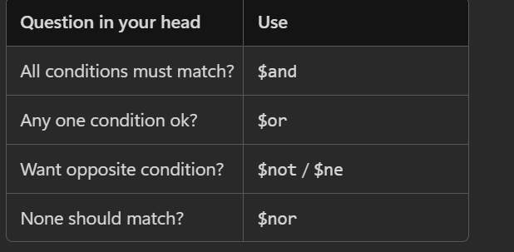
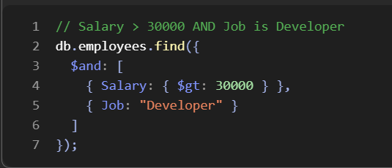
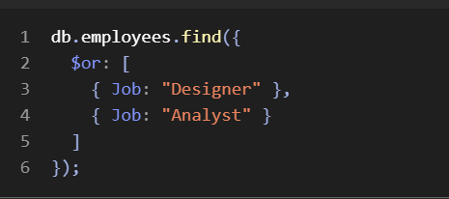
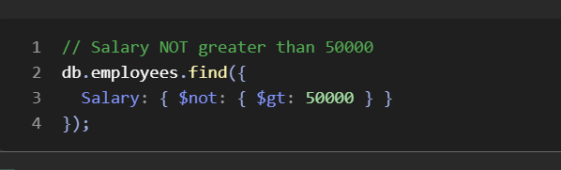
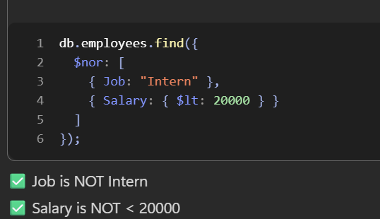
Array Functions:
$push:
-Adds data to array
-if array not exists..creates and adds
-can add duplicates in array
$addToSet:
-adds data only if data is not in array
-No duplication
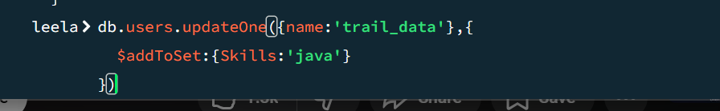
$pull:
-removes the element
-Remove all occurrences
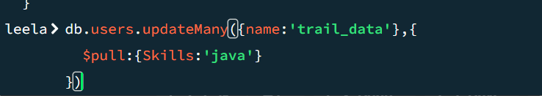
$pullAll:
-Removes all elements of specific data
-Takes array
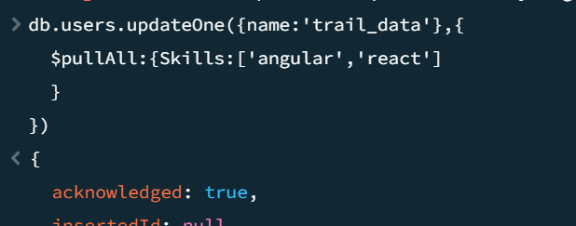
-Removes angular and react and all its occurrences from array
$pop:
-removes element from start /end
- 1 for end …, -1 for start in array


$each: valid with $push and $addToSet
-To Group data
-If $push:{Skill:[‘react’,’angular’]}} it will as an another array in array [[]]
-only used with $Push and $addToSet

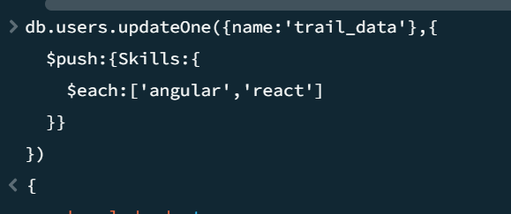
$slice: only valid with $push
-Modifes array
- Negative value-> from last
- Postive value->from 1st
- Must use with $each in update
- -Not allowed $slice directly
-Used in 2 ways…for projection… for modification
-Standalone for find()
-$each must be used in update
$position: only valid with $push
-used to push at certain index
-Only wih $push
-pos starts with 0
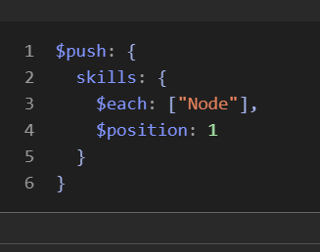
-Must use with $each
$elemMatch:
-returns an document that has values of passed document
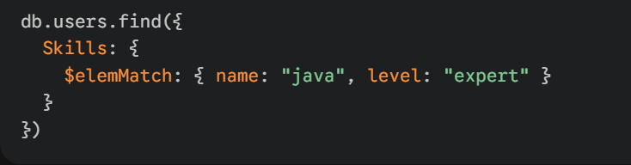
Why not db.users.find({“Skills.name”:’java’,”Skills.level”:”expert”})??
If we have data like
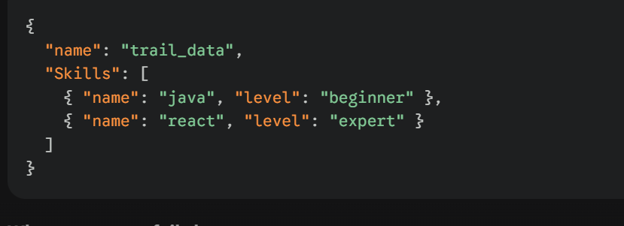
Then it checks name=java and level =expert of 2nd obj
But we need java and expert at a time
So we use $elemMatch
-Imppppppppp: we can access arraname.obj_key like Skills.name
$:Postional operator
-Position Operator
-Deals with nested documents
$ is placeholder for index
Here 2 things
-Filter must point to Document / property so that $ will have that index
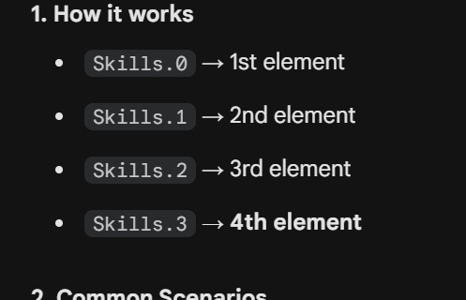
-Filter is must
-else mongo cant get index
$[]: all position Operators
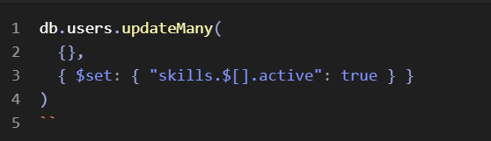
-adds in all nested documents
-Array must contain documents only

$[filter]: Filtered Postion
$ ->depeneds main fikter
$[filter]->depends on arrayFilter
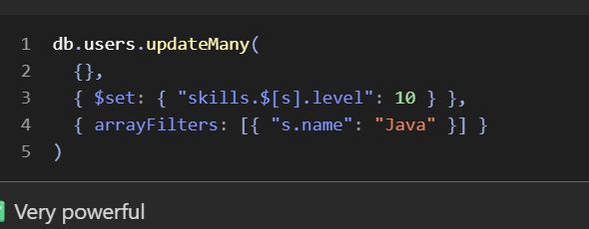
arrayFilter always takes array with multiple conditions
-Each condtion must encapsulated in {}
-Used in nested documents only
- here s is document of users collection
$size:
-used to get size


$all:
-Array must contain all data
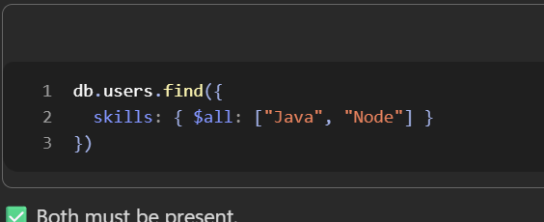
$exists: bool
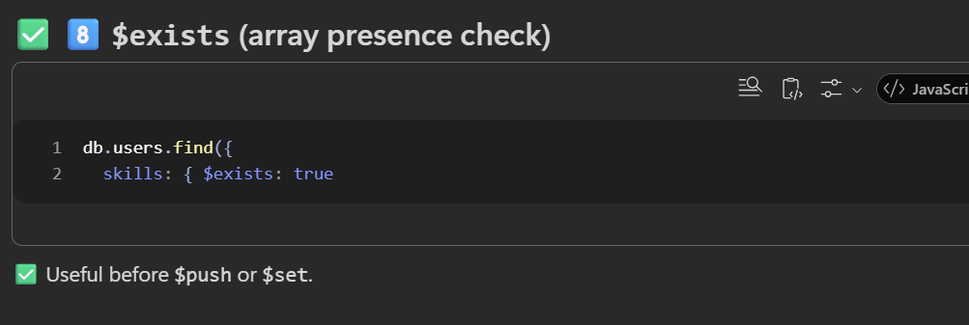
Aggregate Pipelines:
-Summarizing / transforming multiple documents
-Used for analysing data
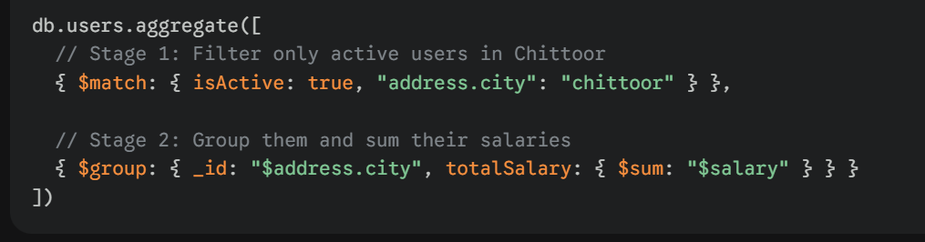
-These one by one operations are stages
-All stages are written in a array which is pipeline
-order matters
-Stages can be repated again unlike find
Stages:
1.Match
-just like find,,but find() is not used in aggregation
-filters data
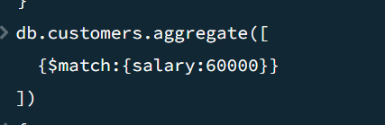
2. Group:
-groups data
-$ is must for each value in group
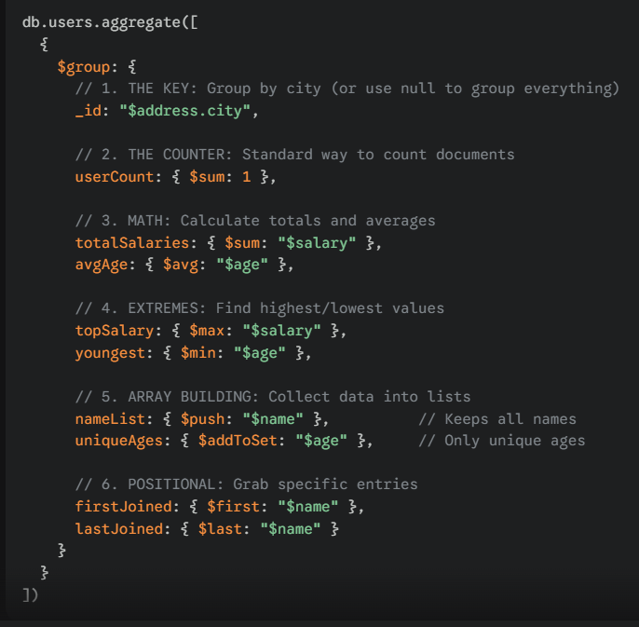
-id: required group data ..groups based on data we put here
-it is standard and it should be _id only
userCount:{$sum:1} :
here usercount is allias…and $sum:1 it counts the number of documents that fall into each group.
-standard way for count groups
$sum: total sum of provide value
$avg,$min,$max are same as sql
$push: while forming groups..if each group if iit gets new data,.adds into array
$addToSet: same like push but stops duplicates
$first: first data of each group
$last:last data of each group
Note: if first and last used after sort…then it would be better..else it follows physical order
How to group Multiple keys at a time…
Pass as an object:
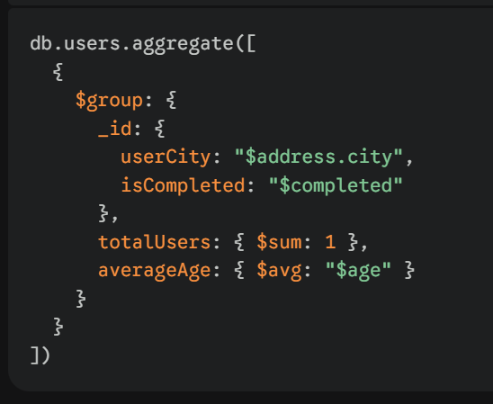
3.project:
-projects data
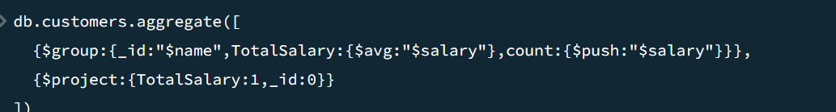
4.sort:
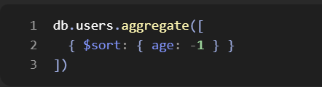
5.limit:
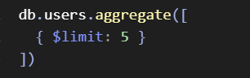
6.skip:
-skips documents
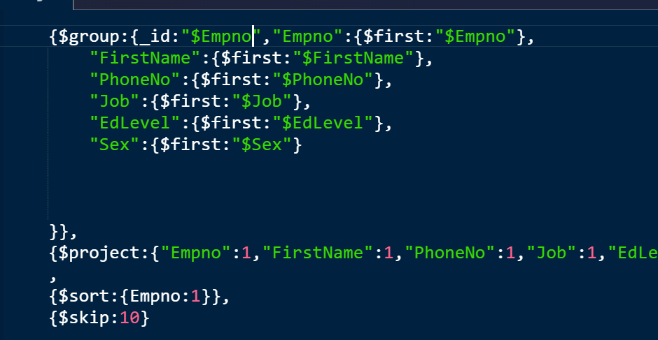
6.count:
-counts all satisfied documents and gives count it got in the current stage (not by any value/attr)
-it wont print data
-Value for $count is customizable ..it is an allais
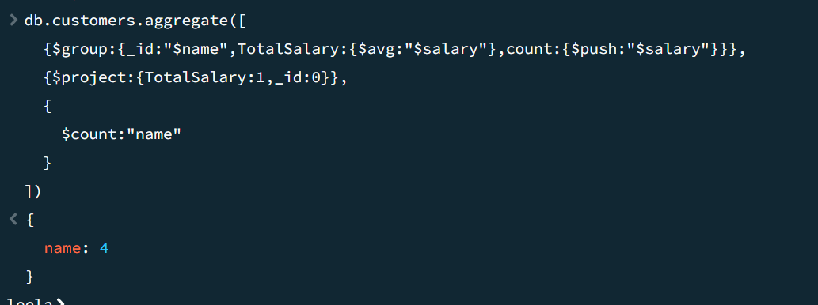
7.unwind:
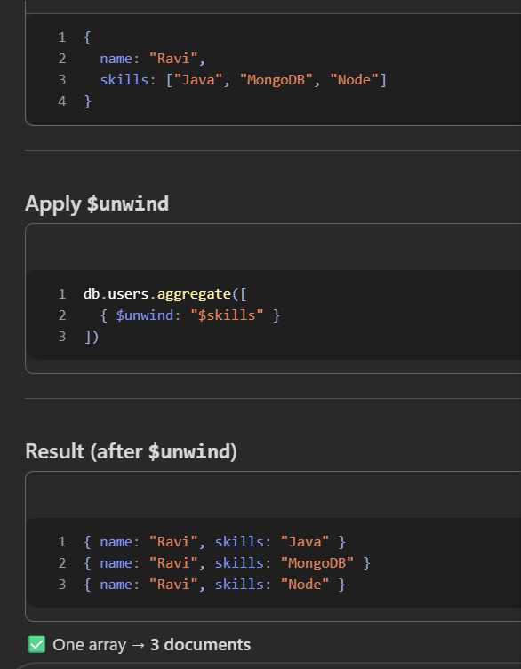
Syntax:
path:array field name
preserveNullAndEmptyArrays: Boolean // if array is null|empty, usually unwind deletes document..so for safety we use this
includeArrayIndex:”name”.. adds a new filed name:indexvalue of element in array before unwind..so that we can reuse later
-For each array element it will create document with same data independently for each element of array
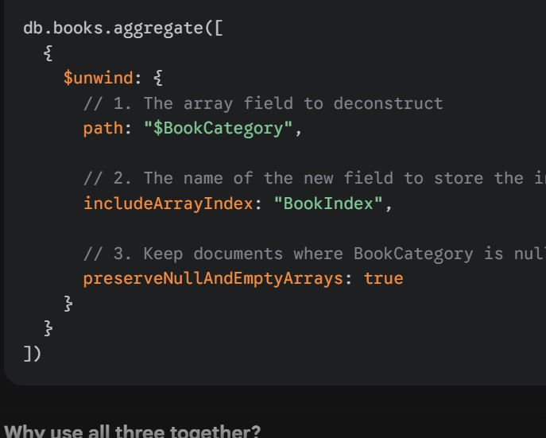
8.$out:
-Makes a new collection with data it got
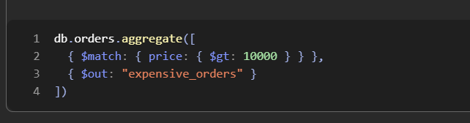
-prints nothing but adds collection
9. $addFields:
_Adds fields in aggregation
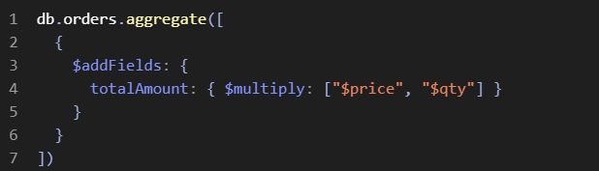
10.$sortByCount:
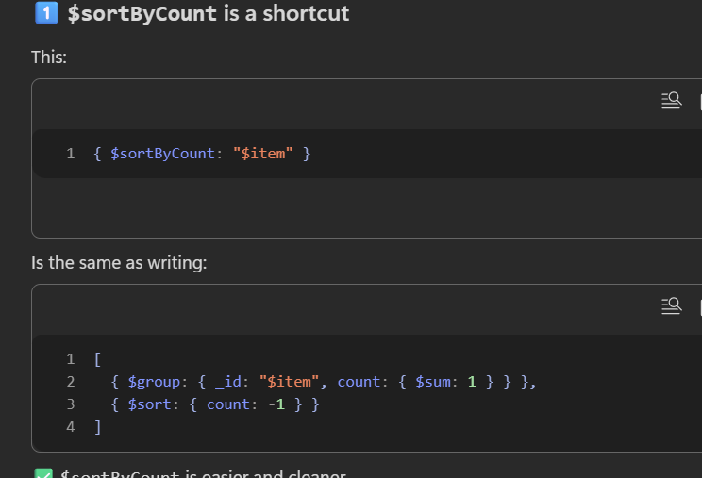
-group ,counts and sorts in desc
Data Aggregation Methods:
1.distinct(required filed, filter):
-return unique
With filter also applied
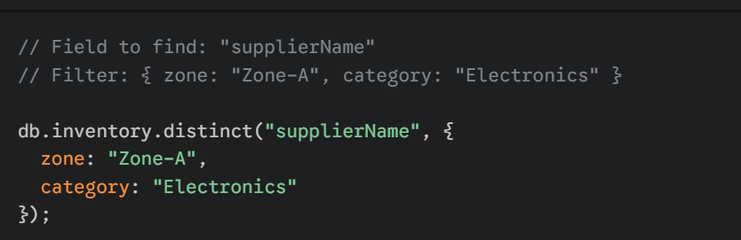
2.countDocuments():

Note:
$product-> means referring value of key
Product -> means referring key
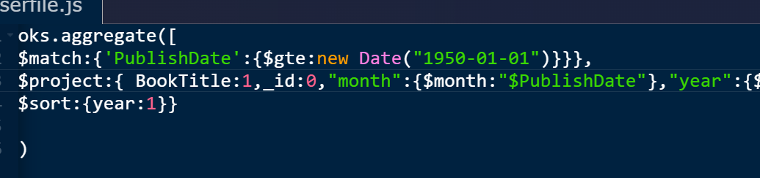
Dealing with Date:
Extraction:
$year for year
$month for month
$dayOfMonth for day
$dayOfYear for yead day
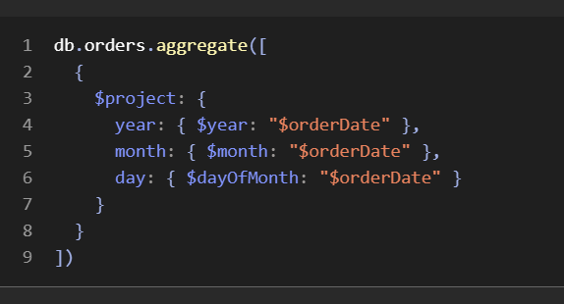
Date Manipulaton:
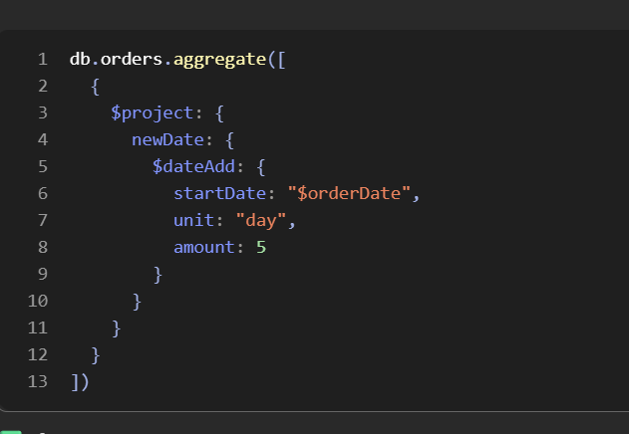
-$dateAdd allows adding or subtracting date
-startDate:current date/date
-unit : “year”|”month”|”day”|”hour”|”minute”|”second”
-amount:number to add/subtract
-positve number->add
-negative number->subtract
DateDiff:
$dateDiff is used
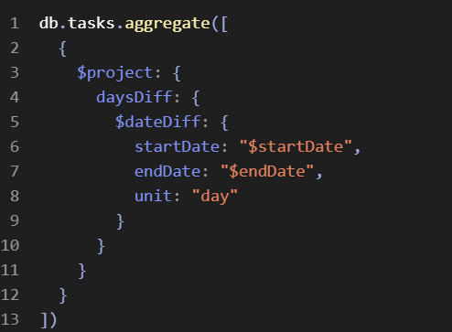
-startdate->date 1 and endDate is date 2 and unti decides gap/diff

Conditional Statements:
- simple if else
-no else if in mongo
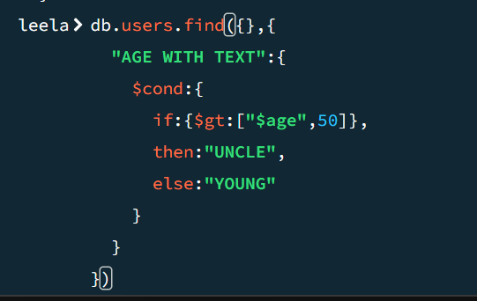
-Here $gt works differently and expects 2 args
-because $gt,$lt works in conditions like this
Switch Case:
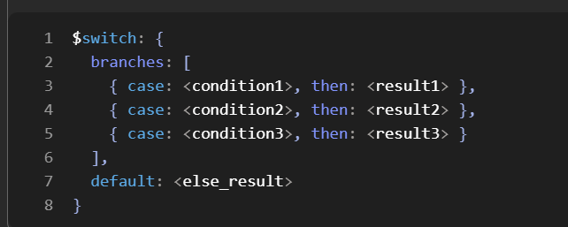
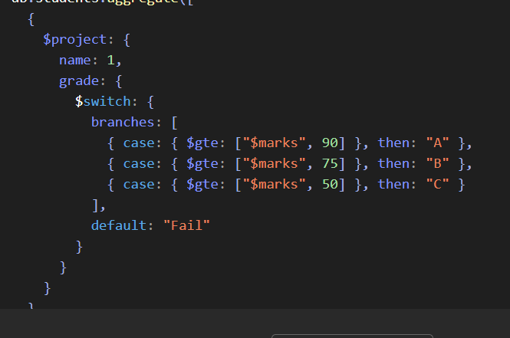
Regex:
-$regex and $options
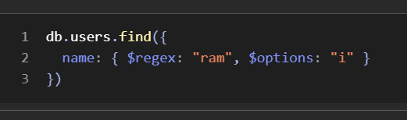
$regex:”^ram” //must start with ram
$regex:”ram” //must include ram
$regex:”ram$” //must end with ram
$options:’i’ is case insensitive
Matching Position:
use .
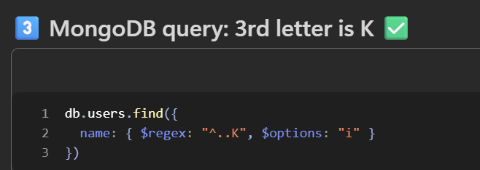
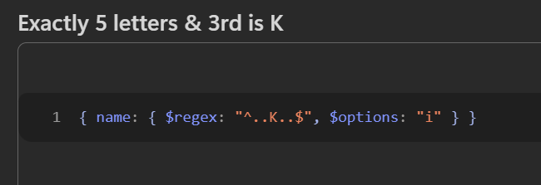

String Functions:
-Must use in aggregations
-Not used any where else
1.toUpper:
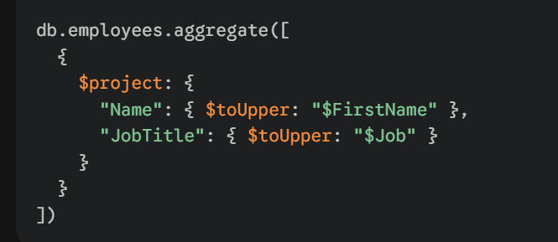
-toUpper throws error if $firstname or value is null
So use $ifNull to avoid error
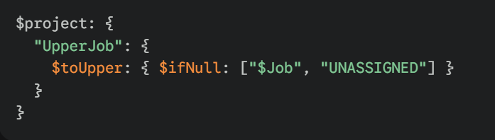
2.toLower:
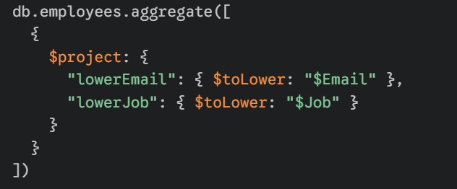
3.concat:
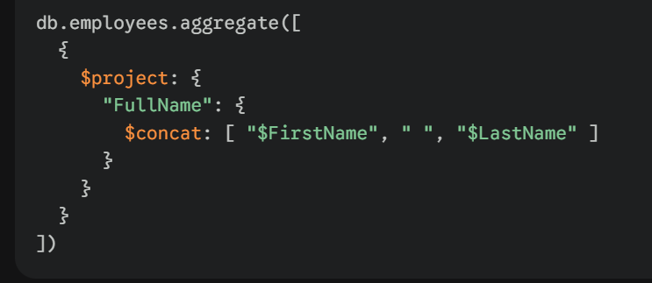
4.length:
-strLenCp is used
-string length code points
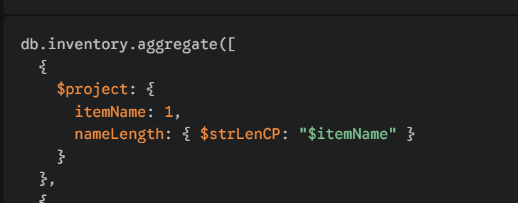
5.substrCP:
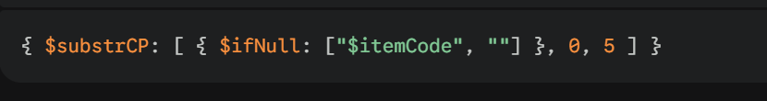
-takes array
-1st arg -data … 2nd arg->start index…3rd arg->length of required string from start
6.replaceOne:
-replaces first occurrence
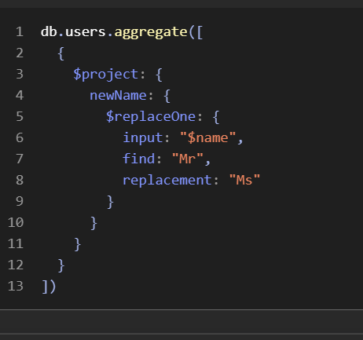
7.replaceAll :
-same syntax
-replace all occurrences
8.trim:
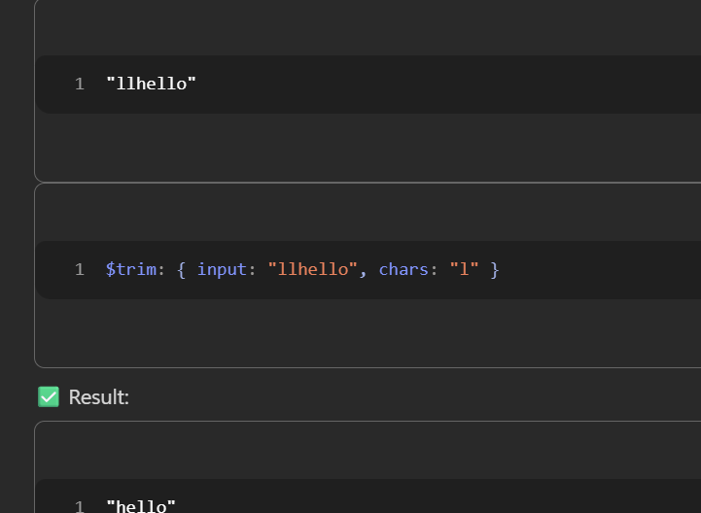
-chars is optional..
-by default trim() removes spaces on front and end
Math Opertions:
1. $ add , $subtract, $ multiply , $divide, $mod
These arthimetic operators takes array of values and return data
Only divide and mod will take 2
Rest can take n
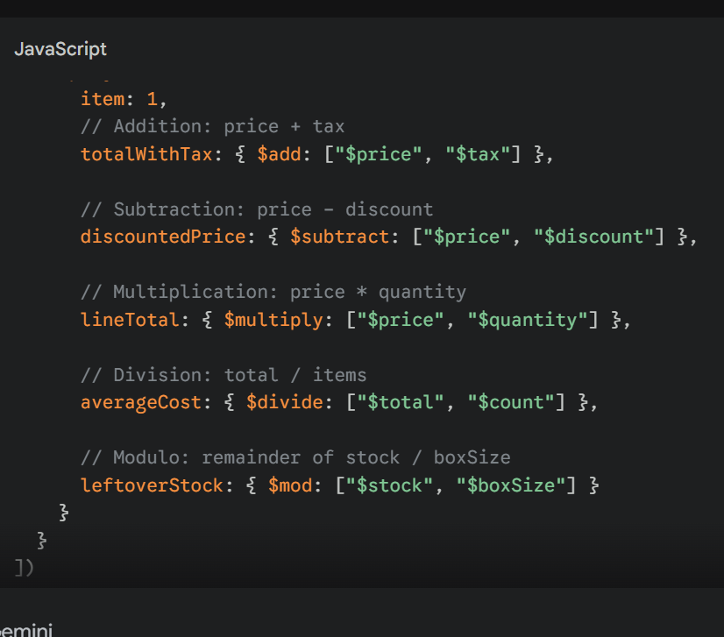
Then
$abs, $floor, $ceil
-Takes value and returns
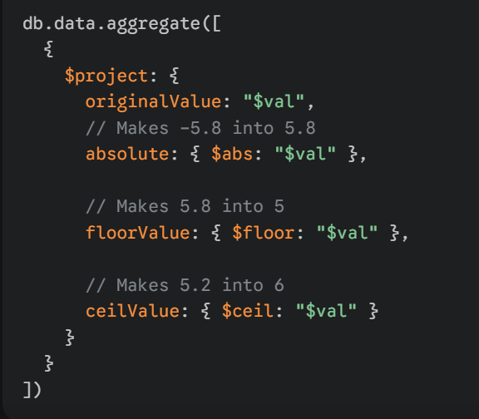
$round:
-takes array but 2nd data is for round n digits

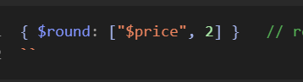

$pow:
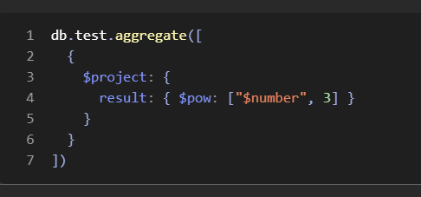

Schema Validation:
- MongoDB is schema less..
-Sometimes it is dangerous
-So we add Rules
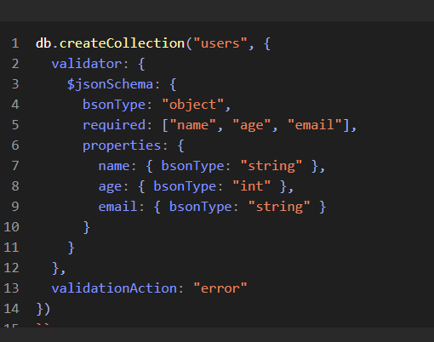
$jsonSchema: tells how Document should be in collection
bsonType: data type …document is object type
required:[] ..these fields are must while adding document
properties:{} for each field adds type of data
data type and keynames should be in camelcase only
int,double,string,bool,null,ObjectId,date,array etc
validationAction:”error”,”warns”
-how to behave when error comes
-warn does not say anything

How to Modify Schema Validation?
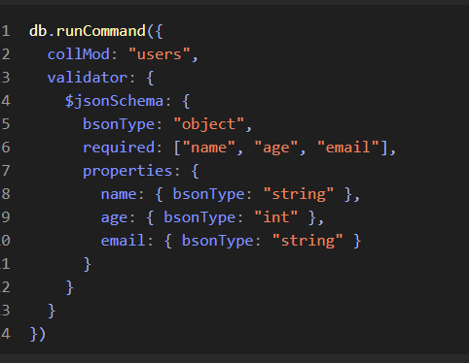
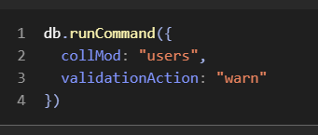
-runCommand is used to run low level/ no helper function commands
-collMod means collectionModification

LookUps:
-To perform joins
-Usually we don’t prefer joins in mongo
-we nest data inside
-But still In some case it may useful
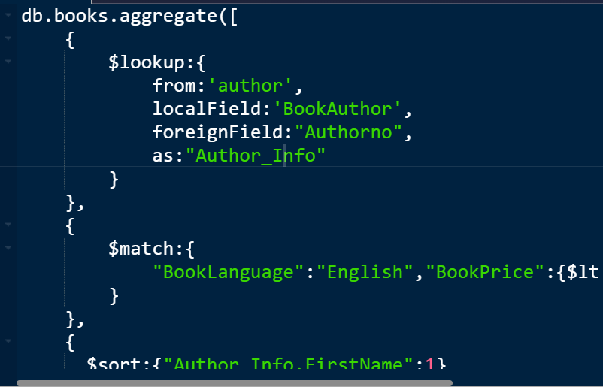
-used in aggregate
-from is another collection name
-localField is current table joining col name
-foreignField:another table col name
-as is for result data storing field name
-returns data with books with array Author_info with author details
Map Reduce:
-used for analyzing complex data
-Older way
-Modern in aggregation pipelines


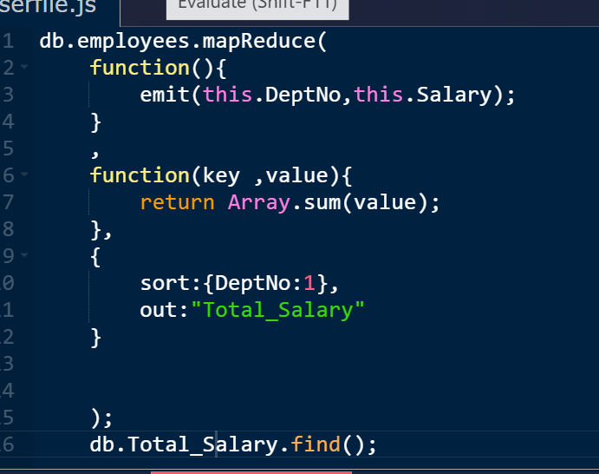
Takes 3 things mapfunc, reduce fn,options
-Runs like js
-Runs on js engine
Map Function:
-Must emit as key and value
-Points to each document in collection
-Extracts data by grouping and emits
Reduce Function:
-Runs for Each group data
-Receievs key and value
-Value as array
-We return data that we want
-For sum-> Array.sum(value) // provided by mongo
-But for avg,min,max …no methods
-We can directly write js logic here to return
-return type must be same return type of map emit value
-many issues if return type is mismatched
Options:
1.out:
-outputs collections
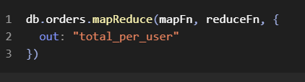
-outputs new collection
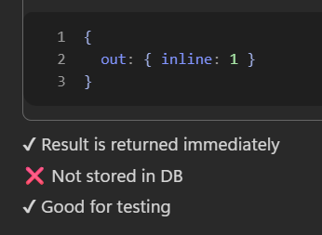
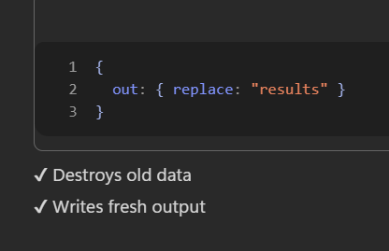
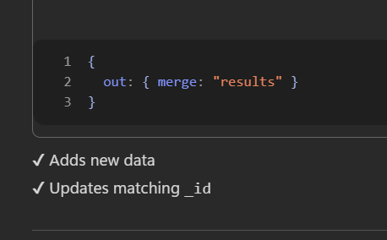
2.sort:
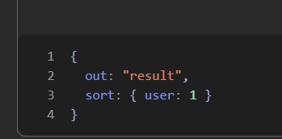
3. query;
-just like match and find()
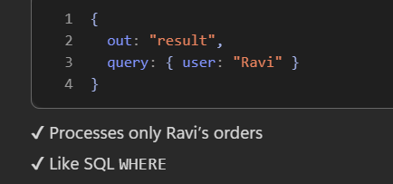
4.limit:
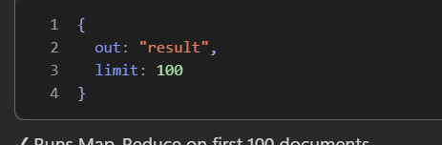

Text Search:
-used for checking text data
-usefull whether a field has particular text or not
-creates index and searches
1.createIndex:
-must
-tells what type of index by adding “text”
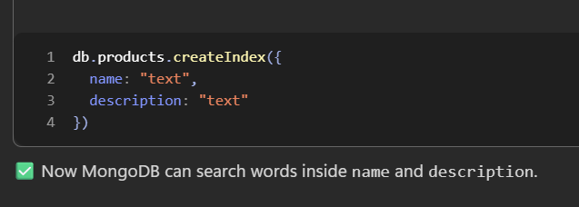
2.$text and $search:
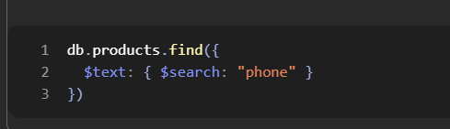
-used in find
-searches words
-searches “phone”
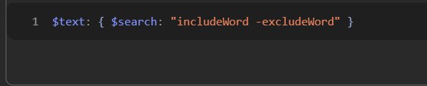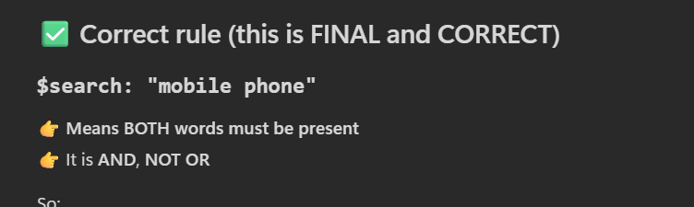
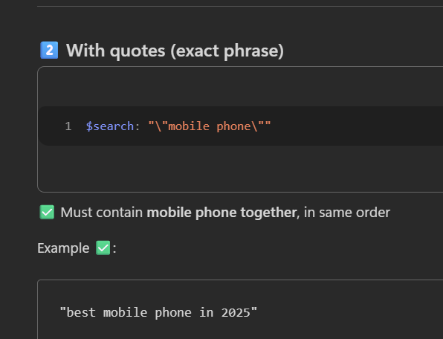
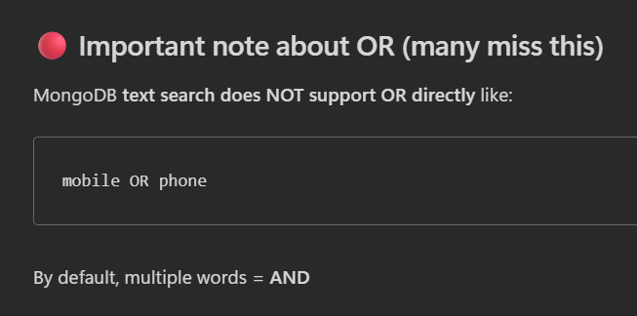

Exclused words means-> return doc that does not contain this word
3.$meta:”textScore”:
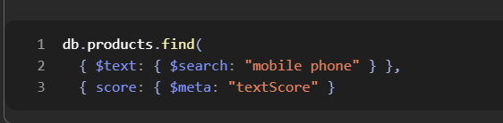
-gives text matcing score
-used in projection
-so score is custom name
We can sort it too
Sorting:


Indexing:
-usually->scans from doc1 to end in a collection when we find()
-indexing -> internally stores as below
Lets say we created index for name
Value_of_name……….-> mapped with respective name=value documents reference internally
-So Mongo Can work faster
1.createIndex:
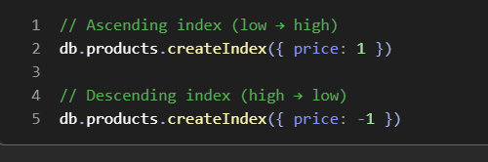
-internally index storing order decides 1 or -1
2.dropIndex
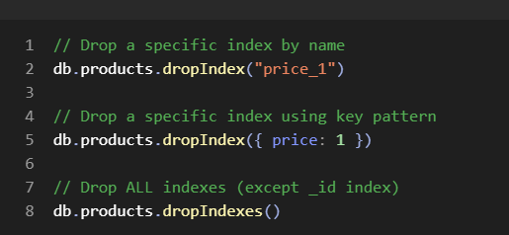
Price_1 means {price:1}..so be carefull..it is not price
3. getIndexes and getIndices() : both are same
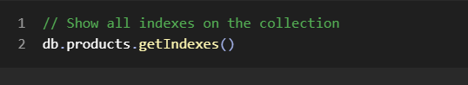
4.options:
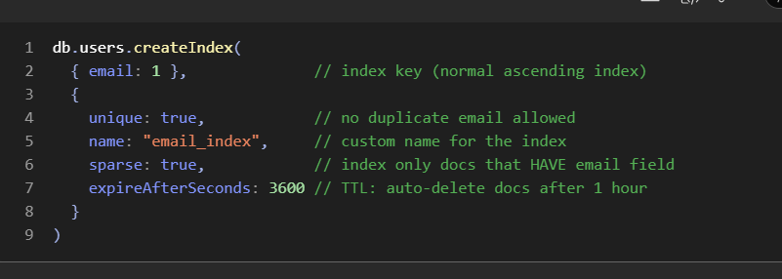
Name-can be used while dropIndex..it is custom
Sparse->wont consider when doc does not have email…so it performs collection scan when we gave value that is not present in index

Mongoose:
-Bridge to connect express to MongoDb
-Wrapper of MongoDb
-Uses methods and syntax is little different
-Every operation is async
Connection:
-use mongoose.connect(mongourl/dbname):
-if db does not exist..it will create
-it is a promise
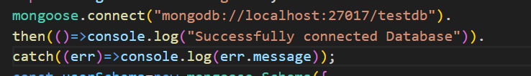
Schema:
-Mongo is schema less
-mongoose allows to use schema
-We must create schema for a collection before creating it
-use mongoose.Schema({})
-use constructor functions inside instead of primitive type
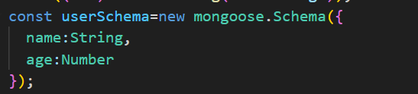
Model:
-means collection
-must define a collection name and schema
-use mongoose.model(name of coll, schema name):
Creating /Insert Data:
-methods .create() and create([])
Adding single data:
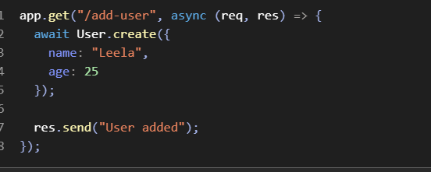
Adding Multiple Data:
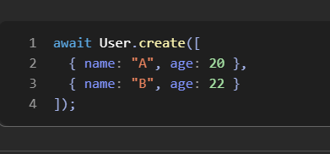
Reading Data:
methods: find(), findById(), findByOne()
Find():
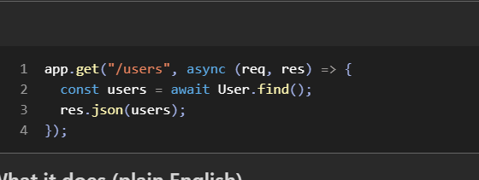
findOne():
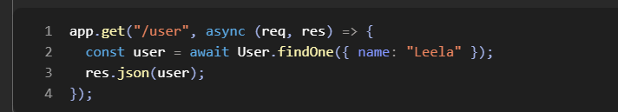
findById():
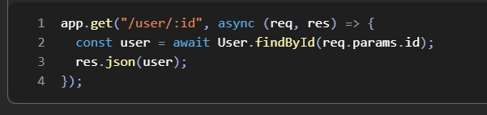
Updating Data:
-methods updateOne, updateMany, findByIdAndUpdate()
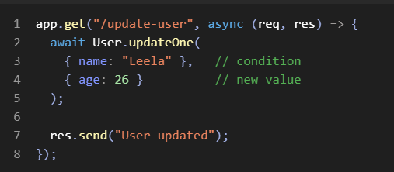
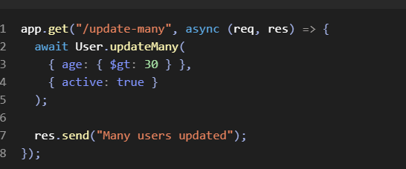
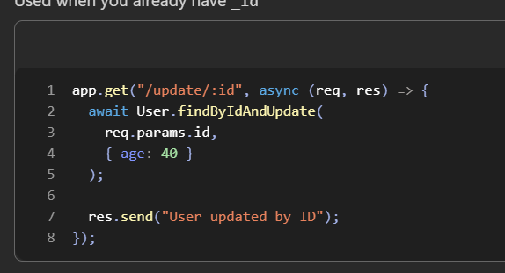
Delete:
-methods deleteOne , deleteMany, findByIdAndDelete()
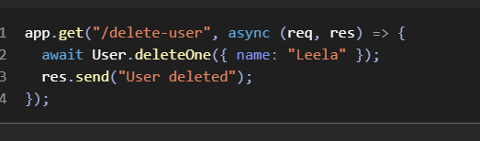
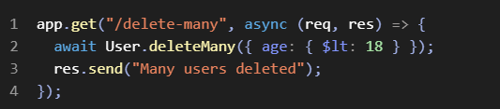
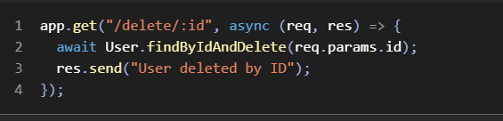

Aggregation:
-aggregation is same in mongoose
-syntax also same
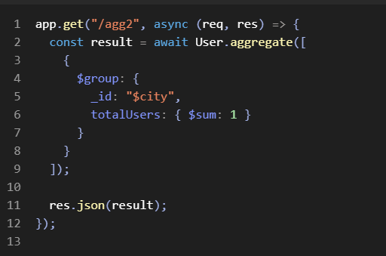

Note:
-schema has many methods
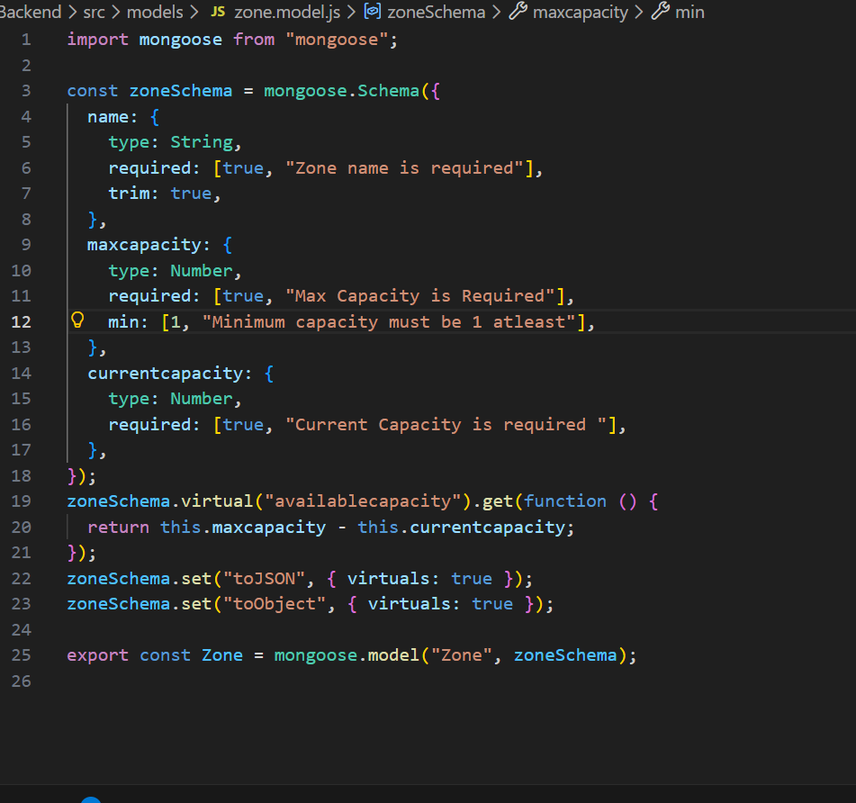
For each field we can give certail options
Type, required, default,unique, trim, min,max,minlength,maxlength,match ,validate
-match takes regex
-validate takes function
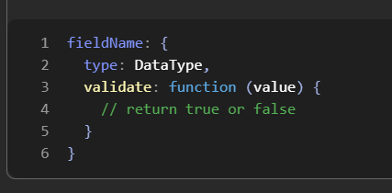
-some of them can take array..where 1st value is value and 2nd is error msg if it does not satisfy
Virtual:
-allows a field to be on viratual instead of storing in mongo
-.virtual(fieldname).get(normal function)
-this refers to schema only
-no arrow function ..since it raises conflicts in this keyword
Set():
-usually this virtual wont be everywhere
-while res.json() it may not include this virtual fields..
-toObject means usually monogoose returns mongoDb object when we use find() etc..
So to convert into js object we have toObject method

Zone.toObject()
-so here we may miss virtual fields
-so we set it manually

